Title of the contribution

First Author¹, Second Author¹, Third Author² (First Name Last Name)
¹Author(s) affiliation, Country
E-mail: author1@xxx.yy; author2@xxx.yy
² Author(s) affiliation, Country
E-mail: author3@xxx.yy

Keywords: Keyword1, keyword2, keyword3.

These instructions give you guidelines for preparing the two-page short paper for the 15th International Workshop on 1&2 Dimensional Magnetic Measurement and Testing (2DM 2018), which will be held on 24-26 September 2018 in Grenoble, France.
Here is the body of the abstract. Please summarize the motivations of the contribution, the methodology used, the main results achieved (including important equations and representative figures to highlight the main achievement). Acknowledgements and selected references have to be placed at the end. Please contain all the text in two pages. One-page papers may be included into the workshop program as well.
The deadline for abstract submission is March 26, 2018. All abstracts must be submitted in PDF format directly on the conference website via the online submission system. No other file formats will be accepted. Acceptance will be notified to the corresponding author by June 01, 2018. The registered authors of accepted digests can submit full papers for publication on the International Journal of Applied Electromagnetics and Mechanics. The manuscripts will follow the regular peer reviewing process of the journal. For any further information, please contact the workshop organizers at 2dm2018@sciencesconf.org.
All text throughout the paper should be written in Times New Roman single-spaced, and respect the following font sizes: 20pt should be used for title, 12pt for author’s name, 10pt for author’s affiliations and e-mail, 10pt for keywords, 10pt for main text, 9pt for figure and table captions, 10pt for references. If you use nonstandard fonts for special symbols, please embed them in the PDF (export option).
Number citations consecutively in square brackets [1]. The sentence punctuation follows the brackets [2]. Multiple references [2], [3] are each numbered with separate brackets [2]-[3]. When citing a section in a book, please give the relevant page numbers [2]. In sentences, refer simply to the reference number, as in [3]. Do not use “Ref. [3]” or “reference [3]” except at the beginning of a sentence. Papers that have not been published should be cited as “unpublished” [4]. Papers that have been submitted for publication should be cited as “submitted for publication”. Papers that have been accepted for publication but not yet specified for an issue should be cited as “to be published”. Please give affiliations and address for private communications. Use a space after authors’ initials. Capitalize only the first word in a paper title, except for proper nouns and element symbols.
Place figures and tables in the middle of columns. Figure captions should be left justified below the figures; table captions should be centered above the tables. Please use words rather than symbols to label the axes. For full use of the width of A4 page, it is encouraged to separate a figure into two sub-figures (a) and (b) put side by side.

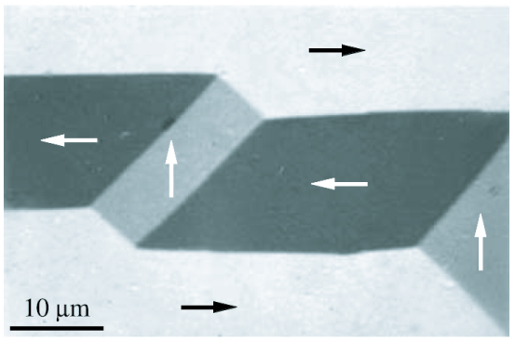
Figure 1: Domain and wall images from a (100)-oriented silicon-iron crystal [2].

Acknowledgements

The research leading to these results has received funding from the European Research Council under the European Union’s Seventh Framework Programme (FP/2007–2013)/ERC Grant Agreement No. XXXXXX (ERC Starting Grant …).

References

[1] Appino, C., Fiorillo, F., "A model for the reversible magnetization in amorphous alloys", J. Appl. Phys., 76 (1994), 5371-5379.
[2] Hubert, A., Schäfer, R., "Magnetic Domains", ed Springer, Berlin (1998), 38.
[3] Sievert, J., ``Recent advances in the one- and two-dimensional magnetic measurement technique for electrical sheet steel'', IEEE Trans. Magn., 26 (1990), 2553-2558.
[4] Gilbert, T. L., "Formulation, Foundations and Applications of the Phenomenological Theory of Ferromagnetism", Ph.D. dissertation, Illinois Inst. Tech., Chicago, IL, (1956), unpublished.

